

Deep Learning Assignment

Project Title: Early Detection of Soil Erosion Using Deep Learning Approach

ID | Name of the Student | Remark
DBU1501482 | Surafel Asfawosen
DBU1501397 | Nardos Molla
DBU1501062 | Bethelehem Asres
DBU1501631 | Ephrata Yeshaneh
DBU1501024 | Beimnet Yealembirhan
DBU1501656 | Yonatan Kiros
DBU1501050 | Besufekad Ayalkbet

Supervised: Baye Y. (Ph.D.)
Submission Date:1/1/2026
Table of Contents
Project Title: Early Detection of Soil Erosion Using Deep Learning Approach 1
List of Tables 3
List of Figures 4
Abstract 5
1. Introduction 6
2. Statement of the problem 7
2.1 Problem Statement 7
2.2 Motivation for Using Deep Learning (DAE with DEC) 7
3. Objective 7
3.1 General Objective 7
3.2 Specific Objectives 8
4. Project Scope 9
5. Project Methodology 9
5.1 General Methodological Approach 9
5.2 Acquisition and Study Area Characterization 10
5.3 Description of Input Features 10
5.4 Data Preprocessing 12
5.5 Denoising Autoencoder for Latent Feature Extraction 13
5.6 latent features Z 14
5.7 Deep Embedding Clustering (DEC) 14
5.8 Erosion Score 17
6. Discussions and Results 17
7. Conclusion and Future Works Conclusion 21
7.1 Conclusion 21
7.2 Future Work 21

List of Tables

Table 1: Detailed breakdown of the project scope 9

List of Figures

Figure 1: Workflow for unsupervised deep learning-based soil erosion risk assessment using DAE and DEC. 10
Figure 2: Denoising Autoencoder Training Performance (zoomed on Zigzag Regional). 17
Figure 3: A bar chart that shows the 3 clusters . 18
Figure 4: 3D PCA Projection of Latent Space Colored by DEC Cluster 19
Figure 5: latent dimension VS physical variable. 20
Figure 6: Workflow for unsupervised deep learning-based soil erosion risk assessment using DAE and DEC. 20

Abstract

Soil erosion is a critical geo-environmental hazard in Ethiopia, driven by complex and non-linear interactions among terrain characteristics, climatic factors such as rainfall, and vegetation cover. Conventional linear and rule-based soil erosion susceptibility models often struggle to capture this complexity, particularly under real-world conditions where environmental data are noisy, heterogeneous, and incomplete. To address these limitations, this study proposes an unsupervised deep learning–based framework capable of learning generalized and previously unseen patterns of soil erosion risk. The methodology is applied to five woredas—Ankober, Menjar, Kewet, Merabet, and Menze Gera—in the Amhara Regional State of Ethiopia. The framework first employs a Denoising Autoencoder (DAE) to reduce noise and extract robust latent features that represent the underlying structure of the environmental data. These latent representations are then used as input to a Deep Embedded Clustering (DEC) model, which automatically partitions the landscape into distinct erosion susceptibility groups without requiring labeled training data. Finally, the resulting clusters are interpreted using an erosion score–based equation to classify erosion risk into three levels: Moderate, High, and Very High. The proposed approach provides an effective decision-support tool for land managers and policy makers by enabling targeted soil conservation planning and early intervention in high-risk areas.

Keywords: Soil erosion, Encoding, DEM, Decoding, Latent space, Geospatial data, Denoising autoencoder, Deep embedded clustering, Erosion score.

- Introduction

Soil erosion is one of the most serious forms of land degradation in Ethiopia, posing a significant challenge to environmental sustainability and agricultural productivity. It leads to the removal of fertile topsoil, which is essential for crop growth, soil moisture retention, and nutrient availability. As a result, soil erosion directly reduces crop yields and undermines the long-term productivity of agricultural land, which is the backbone of rural livelihoods in the country.
The problem is particularly severe in the Amhara Regional State, where natural and human-induced factors interact to accelerate erosion processes. Steep slopes and rugged terrain increase surface runoff, while weak vegetation cover limits the soil’s natural protection against rainfall impact. In addition, intense and highly seasonal rainfall further intensifies soil loss, especially during the rainy season when large volumes of water flow rapidly across exposed land surfaces. Unsustainable land-use practices, such as deforestation and improper farming techniques, also contribute to the severity of erosion in the region.
Beyond environmental degradation, soil erosion has profound social and economic consequences. Farmers experience declining agricultural productivity, increased reliance on chemical fertilizers to compensate for nutrient loss, and rising production costs. These challenges increase vulnerability to food insecurity and threaten household incomes, particularly for smallholder farmers who depend heavily on rain-fed agriculture. Consequently, soil erosion is not only an environmental issue but also a critical barrier to sustainable development, food security, and economic stability in the Amhara Regional State and Ethiopia as a whole.

- Statement of the problem

Soil erosion has been contributing to low soil fertility and crop yields in many Woredas. Despite its major effects on society, soil erosion is only detected after its negative effects have been realized.

2.1 Problem Statement

Our dataset does not have labeled erosion events or a clear target variable. If we try to force labels or create synthesized targets using simple static methods like the Universal Soil Loss Equation (USLE), the model may become unrealistic.
It may focus only on finding patterns or extracting features that directly hit the target variable. In doing so, other essential patterns could remain undiscovered or ignored. This narrow focus on one single variable reduces the model’s ability to identify richer structures and new, unseen patterns that could be valuable for human understanding.

2.2 Motivation for Using Deep Learning (DAE with DEC)

To overcome these challenges, deep learning offers a more scientifically rigorous, data-driven pathway. The Denoising Autoencoder (DAE) can extract robust features from noisy remote sensing and DEM inputs, while Deep Embedded Clustering (DEC) groups these features into meaningful susceptibility classes without requiring predefined labels. Together, DAE with DEC addresses three key gaps:

- Data Quality Challenge: DAE reduces noise and stabilizes feature extraction.
- Lack of Labels: DEC enables unsupervised clustering, removing dependence on unrealistic synthesized targets.
- Hidden Patterns: The combined framework uncovers non-linear, complex structures that traditional linear models miss.

By directly learning from the data itself, this approach generates objective, reproducible, and stable susceptibility maps. It not only avoids the drawbacks of forced labeling but also provides richer insights into erosion processes, making it highly effective for large-scale policy and land management in the Amhara Region.

- Objective

3.1 General Objective

The main objective of this project is to develop and validate an early Soil Erosion Susceptibility Mapping System for the Amhara Region using an unsupervised deep learning framework (DAE-DEC)

3.2 Specific Objectives

In order to accomplish the overall objective, this study aims to achieve the following specific objectives:

1. To design a robust data preprocessing pipeline that applies advanced geospatial techniques like

- KNN imputation for missing value handling

- Embedding used for categorical variables

- Scaling and transformation for preparing heterogeneous environmental variables by making them in the same range to be suitable for the deep learning model (DAE-DEC).

2. To implement a Denoising Autoencoder (DAE) with 8 dimensional latent using Autoencoder Feature Selection (AFS) techniques in order to identify key features with high relevance and information value in contributing to soil erosion. latent space to learn compressed, nonlinear, and noise invariant feature representations of erosion drivers.

3. In order to cluster the latent feature space by utilizing Deep Embedded Clustering (DEC) to categorize geographical regions with similar erosion patterns into different risk classes of soil erosion. By using erosion score mechanism, we translate the discovered clusters into three operational susceptibility classes: Moderate, High, and Very High erosion risk class.

4. To develop user friendly interactive dashboard that enables visual analytics and supports decision making for erosion risk management of Woredas.

- Project Scope

The scope of this project is defined across four key dimensions

Table 1: Detailed breakdown of the project scope
Dimension | Description
Geographic Scope | Limited to the five woredas (Ankober, Menjar, Kewet, Merabet, and Menze Gera) of Amhara National Regional State, Ethiopia. Spatial comparison among the five woredas will help to explore differences in erosion risk patterns and influencing factors.
Data Scope | Utilizes 150,000 georeferenced data points derived from DEM, satellite imagery (NDVI), and rainfall estimates.
Temporal Scope | The project represents current conditions through a static baseline erosion susceptibility map for the Amhara Region. However, this project does not con-sider time-based forecasting, field measurement of soil loss, and validation from long-term historical erosion  records.
Methodological Scope | Strictly limited to Deep Unsupervised Learning (DAE-DEC) due to the limitation of target variables. The results are expected to be interpreted as an early suspected risk assessment for soil erosion.

- Project Methodology

5.1 General Methodological Approach

Its overall technical process involves this core principal components: data cleaning and preprocessing, extraction of features in the latent space from a denoising autoencoder, and finally clustering through deep embedded clustering and interpretation of soil erosion risk results.

These technical components are formulated to allow a sequential transformation from raw environmental inputs to significant erosion risk classes on a woreda scale. we can see it in this work flow, all steps from starting to end.

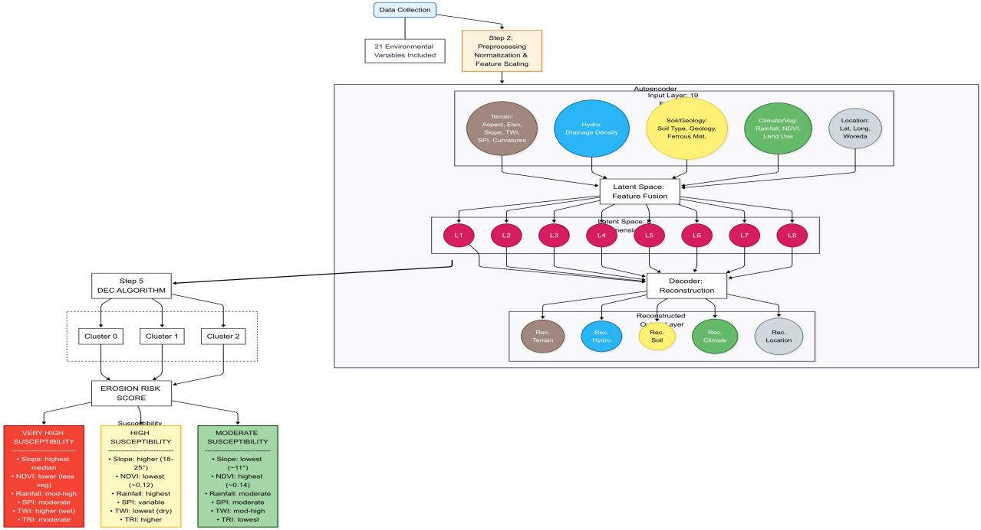
Figure 1: Workflow for unsupervised deep learning-based soil erosion risk assessment using DAE and DEC.

5.2 Acquisition and Study Area Characterization

The study focused on five woredas located in the North Shewa Zone of Amhara Region, Ethiopia, selected for their diverse topographic, climatic, and land-use conditions that influence soil erosion processes: Ankober, Kewet,Merabete,Menze Gera & Menjar.

5.3 Description of Input Features

- Latitude: A geographic coordinate that specifies the north-south position of a point on the surface of the Earth or another celestial body.
- Longitude: A geographic coordinate that specifies the east-west position of a point on the surface of the Earth, or another celestial body.
- Slope: The steepness or the degree of incline of a surface.
- Drainage Density: The measurement of the total length of all streams and rivers within a drainage basin divided by the total area of the basin.
- Elevation: The measurement of height above sea level.
- Ferrous Materials: Metals with iron as one of the main components.
- Geological Formation: A body of rock having a consistent set of physical char-acteristics (lithology) that distinguishes it from adjacent bodies of rock, and which occupies a particular position in the layers of rock exposed in a geographical region.
- Land Use: Human activities like farming or overgrazing expose soil; forested areas have strong protection; bare land erodes faster.
- Normalized Difference Vegetation Index (NDVI): A widely used metric for quantifying the health and density of vegetation.
- Plan Curvature: Describes the curvature of the land surface in a horizontal plane.
- Profile Curvature: Represents curvature in the direction of slope (vertical pro-file). It affects the acceleration or deceleration of water flowing downslope.
- Rainfall (mm): Shows how much rain an area receives.
- Aspect (Degree): Shows the direction a slope faces (north, south, east, west). It influences sunlight exposure, temperature, and moisture levels.
- Soil Type: Determines erosion susceptibility based on texture (sand, silt, clay).
- SPI (Stream Power Index): Measures the erosive power of flowing water. NASA’s Earth satellites collect NDVI data to measure the” greenness” of vegetation.
- TPI (Terrain Ruggedness Index): Measures how rough or uneven the surface is.
- TRI (Terrain Ruggedness Index): Measures how rough or uneven the surface is.
- TWI: Estimates how much water accumulates in an area and how wet the soil re-mains. High TWI values indicate zones with poor drainage and persistent moisture.

5.4 Data Preprocessing

- Missing Value Imputation: Missing values occurred primarily in the Stream Power Index (SPI),Drainage Density and Terrain Ruggedness Index(TRI) in continuous variable, Geology formation and soil type in categorical variable. To handle this we were imputed using K-Nearest Neighbors (KNN) imputation with k=5 closest neighbors, which leverages spatial proximity to preserve local geographic patterns more effectively than simple global statistics(mean, mode)

- Categorical Encoding: Categorical variables including Land Use, Soil Type, Ge-ologyFormation, FerrousMaterials by changing using categorical embedding features so they can be used effectively in a deep learning model by converting text-based categories into numerical IDs.We uses TensorFlow’s String Lookup layer to learn a consistent mapping from each unique category value to an integer, while safely handling unseen (out-of-vocabulary) values during inference. Each categorical column is first adapted to the lookup layer to build its vocabulary, then transformed into integer-encoded features that are embedding-ready for our model(DAE-DEC).

- Cyclic Feature Transformation (Sine/Cosine Encoding): The Aspect (De-gree) variable, representing slope direction, is inherently circular (0◦ = 360◦). To properly represent this periodicity and avoid discontinuity at the 0◦/360◦ boundary, Aspect was transformed into two new features using trigonometric functions:
Aspect sin = sin(Aspect × π/180)
Aspectcos = cos(Aspect × π/180)

This transformation preserves angular relationships (e.g., 1◦ and 359◦ are close in value) and this particularly beneficial our model learning directional patterns in erosion processes.

- Feature Scaling: Several scaling techniques were evaluated to ensure compatibility with our model like
- Slope Degree → Slopepercent: Converted slope degrees into slope percent using tan(θ) transformation. This preserves the raw slope degree for dashboard visualization while providing a normalized slope measure for modeling.
- NDVIValue → NDVIscaled: Applied Min-Max Scaling (0–1 range) to normalize vegetation index values. Raw NDVI is retained for interpretability in dashboards.
- Rainfall mm → Rainfall logscaled: Applied log transformation (log(1+x)) to reduce skewness in rainfall distribution. Raw rainfall values are kept for visualization.
- Hydrological variables (Drainage Density, SPI, TWI, TRI, TPI):Shifted values to ensure non-negativity before log transform. Applied safe log transformation (log(1 + x)) to reduce skewness. Standardized with Standard Scaler (zero mean, unit variance) to stabilize gradients and ensure equal feature contribution in neural net-work training.
- Curvatures (Plan Curvature, ProfileCurvature): Standardized using Standard Scaler. This centers curvature features and normalizes variance, improving convergence in deep learning models.
- Elevation m → Elevation norm scaled: Applied Min-Max Scaling (0–1 range) to normalize elevation values for comparability across regions. Raw elevation retained for dashboard visualization
After applying the appropriate scaling and transformation techniques to each environ-mental and erosion-related variable, the resulting features were assembled into a single input matrix X. This matrix contained both continuous and categorical predictors, ensuring that the autoencoder could learn from a comprehensive representation of the erosion environment.

5.5 Denoising Autoencoder for Latent Feature Extraction

The final feature set combined these continuous and categorical variables into X, which was cast to float32 for compatibility with TensorFlow. A training/validation split (80/20) was then performed to prepare the data for the de-noising autoencoder.
To ensure consistency of results, random seeds were fixed across Python, NumPy, and TensorFlow Deterministic operations were enforced so that the training process yields consistent outcomes across runs. This step is critical in deep learning experiments, where stochastic initialization and GPU parallelism can otherwise lead to slightly different latent representations and reconstruction errors.

Rather than adding a penalty Ω to the cost function, the denoising autoencoder (DAE) learns useful structure by modifying the reconstruction error term. Traditionally, autoencoders minimize
$$L(x,g(f(x)))$$
where $L$penalizes dissimilarity between the input $x$and its reconstruction $g(f(x))$. This often risks learning the identity function. A DAE instead minimizes
$$L(x,g(f(\tilde{x})))$$
where $\tilde{x}$is a corrupted version of $x$(here, Gaussian noise). The model must therefore learn to undo corruption, forcing $f$and $g$to capture the underlying data distribution
$$p_{data}(x)$$
rather than trivial mappings.

The implemented DAE architecture was:
- Input dimension: $d=20$(continuous + categorical features)
- Noise: Gaussian noise ($σ=0.05$) applied to inputs
- Encoder: Dense(64 → ReLU) → Dense(32 → ReLU) → Latent space (8 dimensions, linear activation).
  - The numbers 64 and 32 denote the number of neurons in each hidden layer.
  - A larger layer (64 neurons) captures more complex feature interactions, while the smaller layer (32 neurons) progressively compresses the representation before reaching the latent space.
- Decoder: Dense(32 → ReLU) → Dense(64 → ReLU) → Output layer (linear, dimension $d$).
  - The decoder mirrors the encoder, expanding the latent representation back to the original feature dimension.
- Activation function (ReLU):
$$f(x)=max⁡(0,x)$$
It introduces non-linearity, allowing the network to learn complex relationships, while avoiding vanishing gradient problems common with sigmoid or tanh activations.
- Optimizer: Adam (Adam optimizer adjusts network weights by adaptively scaling learning rates using gradient momentum and variance estimates.)
- Loss: Mean Squared Error (MSE) between clean input $x$and reconstruction $g(f(\tilde{x}))$
- Training: 40 epochs, batch size 256, early stopping on validation loss

The encoder compresses the original feature space into an 8-dimensional latent representation. This latent space captures non-linear interactions among erosion drivers while discarding noise. The decoder reconstructs the original features from this compact representation.

By training on corrupted inputs, the model learns robust latent features that generalize better to unseen data. The reconstruction loss converged stably, confirming that the autoencoder successfully extracted meaningful structure from the environmental dataset. Moving to an 8-dimensional latent space means that the denoising autoencoder has dis-tilled all erosion and environmental drivers into a compact, noise-robust representation. This latent space captures the essential structure of the data while discarding irrelevant variation, making it easier to analyze, visualize, and use for predictive modeling than the original raw features.

5.6 latent features Z

After training the denoising autoencoder, we use the encoder part to extract the latent features Z. These are the compressed, denoised representations of the original input X. Standardizing X before encoding ensures consistency with the training distribution. The latent features are stored in a Data Frame (latent df), providing a clean and interpretable set of variables that can be further analyzed, visualized, or applied in downstream tasks such as clustering, anomaly detection, or erosion risk modeling.

Furthermore, these latent features serve as the input for the subsequent Deep Em-bedding Clustering (DEC) model, which leverages the compact 8-dimensional representation to perform unsupervised clustering. By operating in the latent space rather than the raw feature space, the DEC model achieves more stable cluster assignments and captures meaningful groupings of erosion-related patterns.

- Notice all outputs are depend on your extracted latent features

5.7 Deep Embedding Clustering (DEC)

The idea behind DEC is to take the compact latent features learned by a denoising autoencoder and then perform clustering directly in that latent space. Instead of treating clustering as a separate step, DEC integrates it into the learning process so that the clusters and the representation reinforce each other.

Step 1: Initialization with K-Means
We begin with the latent features $Z$(for example, 8-dimensional vectors). To avoid starting from random cluster centers, we run KMeans first. This gives us:
- Initial cluster centers $μ^{(0)}$
- Initial assignments $y^{(0)}$
Mathematically:
$$y^{(0)}=arg⁡\underset{j}{min⁡}∥z_{i}-μ_{j}^{(0)}∥^{2}$$
This step ensures the model starts with a reasonable partition of the latent space.
Step 2: Clustering Layer (Student’s t-distribution)
Next, we define a special clustering layer. Instead of hard assignments, it computes soft probabilities that each point belongs to each cluster. The formula uses a Student’s t-distribution kernel:
$$q_{ij}=\frac{{(1+\frac{∥z_{i}-μ_{j}∥^{2}}{α})}^{-\frac{α+1}{2}}}{\sum_{j^{'}}{}{(1+\frac{∥z_{i}-μ_{j^{'}}∥^{2}}{α})}^{-\frac{α+1}{2}}}$$
Here:
- $q_{ij}$is the probability that point $i$belongs to cluster $j$.
- $α$controls the shape of the distribution (usually set to 1).
- Points closer to a center get higher probabilities, but every cluster gets some weight.
This layer is what makes DEC different from plain KMeans — it allows soft, differentiable assignments.
Step 3: Target Distribution
If we only used $q_{ij}$, clusters could become imbalanced or too soft. To fix this, DEC defines a target distribution $p_{ij}$:
$$p_{ij}=\frac{q_{ij}^{2}/\sum_{i}{}q_{ij}}{\sum_{j^{'}}{(q_{ij^{'}}^{2}/\sum_{i}{}q_{ij^{'}})}}$$
This does two things:
- Sharpening: Squaring $q_{ij}$makes confident assignments stronger.
- Balancing: Normalization ensures clusters don’t collapse or dominate.
So $p_{ij}$is like a “teacher distribution” that tells the model what the assignments should look like.

Step 4: KL Divergence Loss
The training objective is to make the predicted distribution $Q$match the target distribution $P$. The difference is measured using Kull back–Leibler (KL) divergence:
$$L=KL(P∥Q)=\sum_{i}{}\sum_{j}{}p_{ij}⋅log⁡(\frac{p_{ij}}{q_{ij}})$$
This loss penalizes the model when its predictions $q_{ij}$deviate from the sharpened target $p_{ij}$. Minimizing KL divergence forces the cluster centers to move so that assignments become more confident and balanced.

Step 5: Optimization with Adam
To minimize the KL loss, we use the Adam optimizer. Adam is well-suited here because:
- It adapts the learning rate for each parameter.
- It uses momentum (first moment) and variance scaling (second moment).
- It converges faster and more stably than plain gradient descent.
In DEC, Adam updates the cluster centers smoothly, avoiding oscillations and speeding up convergence.
Step 6: Iterative Refinement
The training loop works like this:
- Compute $Q$(soft assignments).
- Build $P$(target distribution).
- Minimize KL divergence with Adam to update cluster centers.
- Check how many labels changed compared to the last epoch.
- Stop when label changes fall below a tolerance threshold.
This iterative process gradually sharpens clusters and stabilizes assignments.
Step 7: Final Assignments
After convergence, each point is assigned to the cluster with the highest probability:
$$y_{i}=arg⁡\underset{j}{max⁡} q_{ij}$$
These final labels are stored as DEC Cluster in the dataset. They represent robust, unsupervised groupings of erosion/environmental patterns.
DEC begins with K-Means initialization, refines cluster centers using a Student’s t-distribution clustering layer, sharpens assignments via the target distribution, and iteratively minimizes KL divergence with Adam until stable clusters emerge.

5.8 Erosion Score
The variables were summarized using the median to capture central tendency and the interquartile range (IQR) to measure variability within clusters. Clusters with high medians of SPI, TRI, Rainfall, and Slope, combined with low NDVI, indicate areas more prone to erosion. The IQR indicates whether conditions within a cluster are homogeneous (low IQR) or contain extreme values (high IQR).
To quantify the relative erosion susceptibility of each cluster, an erosion score was defined as a linear combination of median values of the environmental variables:
$$ErosionScore_{i}=SPI_{i, median}+Rainfall_{i, median}+TRI_{i, median}+TWI_{i, median}+Slope_{i, median}-NDVI_{i, median}$$
where $i$denotes the DEC cluster.
- The positive terms ($SPI,Rainfall,TRI,TWI,Slope$) increase erosion risk.
- The negative term ($NDVI$) represents vegetation’s protective effect.
- Discussions and Results

It is clear that the performance of DAE–DEC is outstanding when handling geospatial data with noise but without labels for estimating soil erosion, compared with conventional approaches that fail due to the non-linear nature of the data in environments such as the Ethiopian highlands.

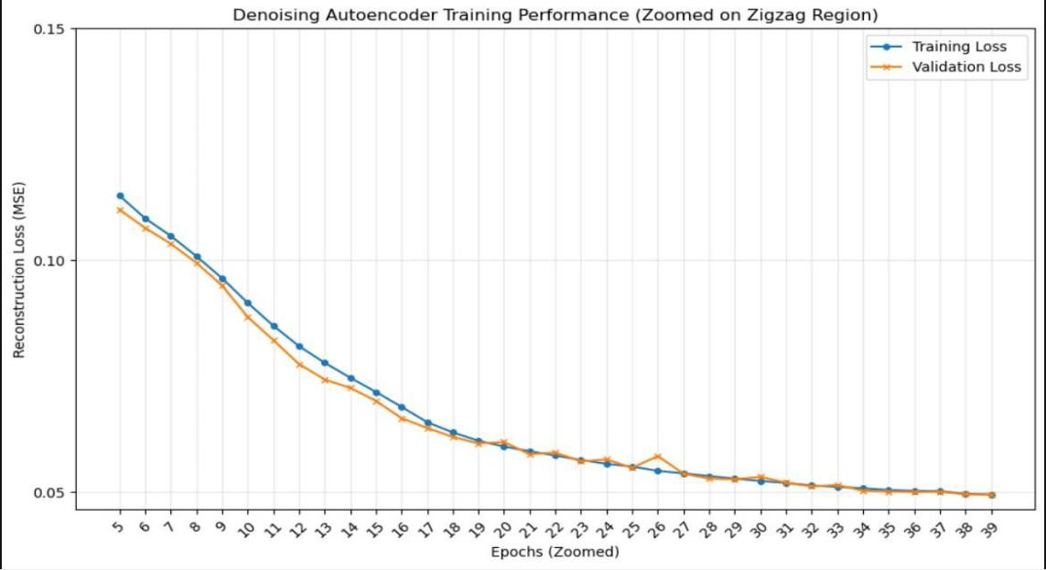
Figure 2: Denoising Autoencoder Training Performance (zoomed on Zigzag Regional).

The training and validation loss curves are steadily decreasing and well follow each other across epochs, which means that the model is learning effectively with a strong generalization and minimal overfitting. This convergence shows that the denoising autoencoder learns robust feature representations rather than memorizing the data. The low reconstruction error affirms the model’s ability to accurately reconstruct the full set of 21 input features after denoising.

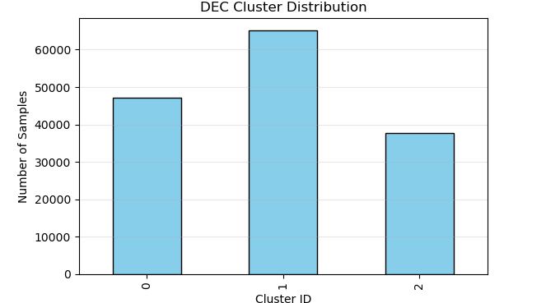
Figure 3: A bar chart that shows the 3 clusters .
Assigning Erosion Risk Labels
Based on the calculated erosion scores, clusters were ranked and labeled as follows:

- Cluster 2 → Moderate Erosion Risk: Lowest erosion score, characterized by lower SPI, TRI, Rainfall, and Slope, and relatively high NDVI. The low IQR indicates homogeneous and relatively stable conditions, reducing erosion susceptibility.

- Cluster 1 → High Erosion Risk: Moderately high erosion score, reflecting intermediate SPI, TRI, Rainfall, and Slope, along with lower NDVI. The IQR shows moderate variability, suggesting some heterogeneity in conditions.

- Cluster 0 → Very High Erosion Risk: Highest erosion score, with extreme median values of SPI, TRI, Rainfall, and Slope, and lowest NDVI. The high IQR indicates heterogeneous conditions with potential local hotspots of severe erosion.

By combining the median values, IQR, and the erosion score, the originally arbitrary DEC clusters are transformed into actionable categories of erosion risk:
This approach allows the DEC model results to be interpreted meaningfully, providing a quantitative framework for identifying areas prone to soil erosion and guiding targeted soil conservation and land management strategies.

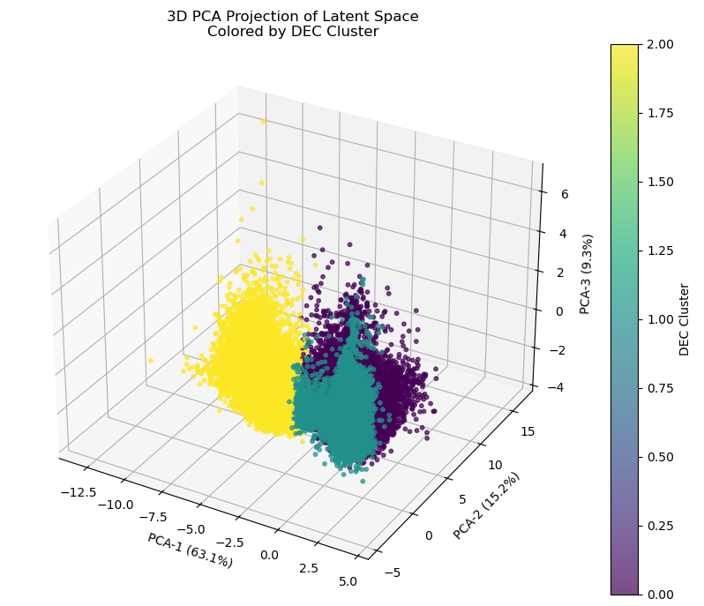
Figure 4: 3D PCA Projection of Latent Space Colored by DEC Cluster
PCA 3D projection of the latent space illustrates how the differentiation of the clusters arises through the cumulative variance explained by the learned latent axes. The first principal component explains about 63.1%% of the total variation, indicating the preponderant factor of environmental variation that delineates high intensity erosion patterns and more stable environments. The second component explains 15.2% variation and identifies the transitional environments, and the third component, which explains 9.3%, captures the detail within the clusters.

Taken together, these three parts describe more than 87.6% of the total latent variance, and the clear demarcation among the clusters in the feature space again confirms the ability of the model to learn effective signatures for the process of soil erosion through the usage of all eight latent features. The model is, therefore, capable of effectively learning different signatures through the group assignments based on the common activation among the samples, rather than among the features.

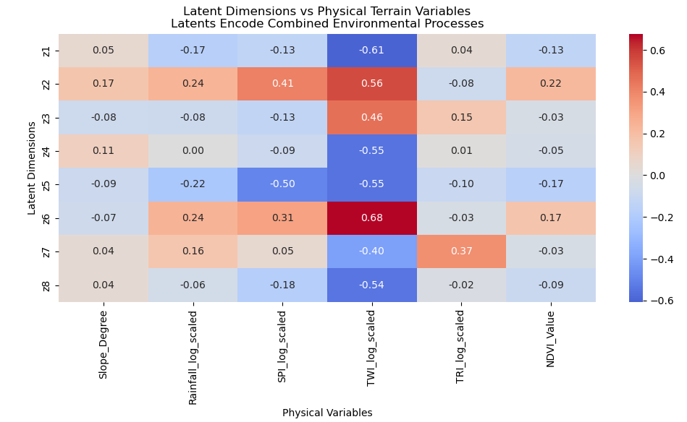
Figure 5: latent dimension VS physical variable.
The chart shows that the latent space captures the information from the 21 input variables equally across the 8 latent dimensions without the dominance of a particular feature. The relatively balanced values of the correlations demonstrate that the latent variables work together in capturing the original features rather than the dominance of a single variable. This verifies that the constructed autoencoder indeed has a well- structured latent space where the equal expression of multiple environmental variables works well in feature compression.

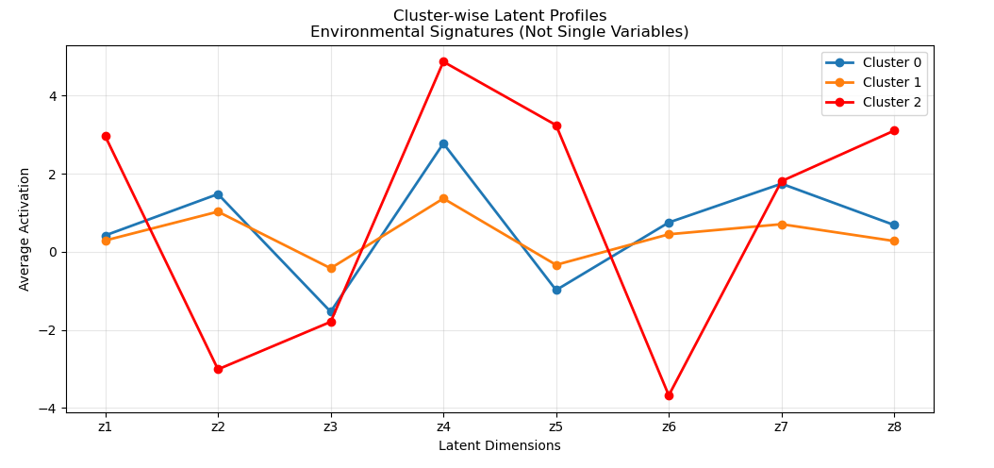
Figure 6: Workflow for unsupervised deep learning-based soil erosion risk assessment using DAE and DEC.
The latent cluster profiles indicate that the learning of the patterns of soil erosion takes into account all eight latent dimensions together, but not any of the eight latent variables individually. The assignments for the clusters are determined by the overall pattern of activation for the set of all eight latent variables, where both positive and negative instances are taken together in such a way that together the patterns are well-defined and meaningful environment signatures.

- Conclusion and Future Works Conclusion

7.1 Conclusion

This work proposed a system to locate regions susceptible to soil erosion as soon as possible by integrating various data sources like maps, terrain characteristics, and environmental information. To address the absence of labeled data about erosion, this work utilized unsupervised deep learning methods, which can identify significant patterns even without pre-existing labeled data.

These latent variables were then applied to the embedded clustering process to cluster the regions according to erosion susceptibility. This was used to categorize the regions by the moderate, high and very high susceptibility to erosion into five target woredas. This combination method applied to the erosion risk map results obtained realistic results that correspond to erosion risk patterns and environmental situations.

The results yielded variations in erosion vulnerability among the woredas, thus stressing the need to apply site-specific approaches in land management. In summary, this study clearly indicates that unsupervised deep learning can be used as a tool in early assessment of soil erosion in an area where little information exists.

7.2 Future Work

We want to our model to be good and problem solver to be more workable and handled environmental features we must contain this to the model the listed things:
- Real-time and seasonal modeling: We plan to integrate real-time and near-real-time data streams, allowing the system to capture temporal and seasonal variations in erosion dynamics more effectively.
- Stronger validation and enrichment: By expanding datasets and incorporating additional environmental indicators, we aim to enhance the reliability and robustness of the model’s predictions.
- Advanced spatial techniques: Future work will explore more sophisticated spatial modeling approaches to represent erosion processes with greater accuracy across diverse landscapes.
- Operational deployment: A key goal is to transition the system from research to practice, supporting decision-makers and land managers with actionable insights for soil conservation and sustainable land use.
Beyond these improvements (to fix the over fitting and class misbalancing ), we envision a hybrid learning framework that combines the strengths of unsupervised and supervised approaches. By merging reconstructed values with the original input data, we can create labeled datasets that enable supervised models to exploit both raw and refined features.
This hybrid strategy offers the best of both worlds:
- The exploratory power of unsupervised feature extraction.
- The predictive strength of supervised learning.
Together, these elements promise improved performance, stability, and generalization. Ultimately, the model becomes more robust, accurate, and practical, closing the gap between theoretical innovation and real-world application.

Reference
- https://www.geeksforgeeks.org/machine-learning/auto-encoders/
- https://deepwiki.com/vlukiyanov/pt-dec

